ICT 202
Assignment 1: Small-scale literature review and implementation assignment

- Introduction:
Recent advances in machine learning have led to highly accurate but opaque” black box” predictive models across domains such as environmental monitoring, agriculture, industry, and healthcare. This lack of transparency raises concerns about trust, accountability, and practical decision-making, especially when predictions influence high-stakes outcomes such as clinical diagnoses, resource allocation, or environmental management. Explainable Machine learning aims to address this challenge by providing human-understandable accounts of model behaviour, and future-attribution techniques such as SHAP and LIME have become prominent for tabular predictive modelling because they expose which features drive individual predictions and overall decision logic.[1]
Despite this progress, most empirical work with SHAP and LIME has focused on classification or discrete decision problems, and only a few studies have examined whether these tools provide stable, physically meaningful explanations for continuous industrial processes such as power-plant operation. Recent applications in geoscience, agriculture, water quality, and fault diagnosis suggest that feature-attribution methods can align model behaviour with domain theory and support model simplification, yet they also hint at unresolved issues regarding explanation stability, feature correlations, and generalizability across sites. Motivated by these gaps, this study investigates whether a tuned Random Forest Regressor model for the Combined Cycle Power Plant dataset can both achieve high predictive accuracy and yield SHAP and LIME-based explanations that are consistent with known thermodynamic effects of ambient conditions on net electrical output. Concretely, we ask (i) how much additional accuracy a nonlinear ensemble offers over a regularized linear baseline; (ii) whether global SHAP patterns and local LIME explanations agree with each other and with power-plant physics; and (iii) what limitations arise when interpreting these explanations for operational decision-making. By addressing these questions, the study provides a small-scale, yet concrete, demonstration of how post-hoc explainability can support the analysis of data-driven power-plant models and highlights practical constraints that should inform future XAI applications in industrial settings. [4]

- Small-scale literature review:
This section reviews five recent computing journal articles published after 2020 that apply explainable machine learning techniques to supervised predictive modelling tasks in geosciences, agriculture, environmental monitoring, and industrial engineering. Across these studies, SHAP and LIME are used to provide global and local insights into models ranging from tree ensembles to neural networks, allowing domain experts to understand which features drive predictions, assess model reliability, and identify potential limitations [1]. When considered together, the five studies illustrate a spectrum of post-hoc explanatory strategies: Three use SHAP for tree-based models to provide both global feature importance and local instance-level attributions, while two combine SHAP and LIME to obtain complementary global and local views for neural or linear models [2]. In all cases, TreeSHAP represents a model-specific variant for ensembles, and LIME serves as a model-agnostic surrogate technique around individual predictions, allowing the authors to preserve high predictive performance while still providing domain-relevant explanation [3].

Across domains, the reviewed articles report similar advantages of explainable machine learning: SHAP and LIME consistently highlight features that align with established domain knowledge (e.g., key geochemical indicators, agronomic variables, pollutant concentrations). Thereby strengthening trust in these models [4]. Several studies also show that XAI can guide feature selection, yielding lighter models with comparable accuracy, and can support user-facing decision tools by exposing the reasons behind individual predictions [5]. However, in most cases, these trust claims are based on qualitative inspection of explanation plots rather than on formal user studies or quantitative measures of explanation usefulness. Some work relies on single train-test splits or limited cross-validation, making it difficult to assess the stability of SHAP ranking across resamples, while others apply LIME without systematically examining how correlated inputs or neighborhood definitions affect local explanation patterns that would generalize to other locations or tasks [4].
Collectively, these studies demonstrate that post-hoc feature-attribution methods can do more than visualize model internals: they can drive feature selection, validate model logic against domain theory, and expose hidden failure models, but their outputs must be interpreted in the context of data and validation limitations. These gaps motivate the present studies’ focus on a well-known UCI benchmark dataset, coupled with explicit cross-validation and side-by-side use of SHAP and LIME, to explore whether similar benefits and limitations arise in the context of continuous power-plant output prediction and to examine the stability and physical plausibility of resulting explanations[1][2][3][4][5].
- Experimental design:

  - Dataset description
This study uses the Combined Cycle Power Plant (CCPP) dataset from the UCI Machine Learning Repository to model net hourly electrical energy output as a continuous target based on ambient operating conditions. The dataset contains 9,568 hourly observations collected over six years (2006-2011) when the plant was operating at full load. The main variables in the CCPP dataset are summarized in Table 1
variable | type | role | Description
AT | Continuous | Feature | Ambient temperature(C)
V | Continuous | Feature | Exhaust vacuum (cm Hg or kPa, dataset-specific)
AP | Continuous | Feature | Ambient pressure(millibar)
RH | Continuous | Feature | Relative humidity (%)
PE | Continuous | Target | Net hourly electrical energy output (MW)

All variables are continuous, which supports the use of regression models and enables fine-grinding SHAP and LIME analyses of how changes in ambient conditions affect power output. For this assignment, the original tabular data are used directly, with PE as the target variable and AT, V, AP, and RH as predictors; the data are randomly split into 70% training and 30% testing sets, preprocessing and hyperparameters and hyperparameter tuning are performed using only the training split and the final models are evaluated on the held-out test set to avoid information leakage.

  - Predictive models:

The primary predictive model in this study is a Random Forest Regressor, selected because it can capture nonlinear relationships and interactions between the power plants’ ambient condition features and net electrical energy output without strong distributional assumptions. As a baseline, a linear Regression model is also trained to provide a simple, interpretable benchmark for comparison with the more flexible ensemble model. Both models are trained on the same training split, and hyperparameters for the Random Forest (e.g., numbers of trees, maximum depth, and number of features considered at each split) are tuned using 3-fold cross-validation grid search on the training data. Model performance is evaluated on the held-out test set using regression metrics, namely Mean Absolute Error (MAE), Root Mean Squared Error (RMSE), and coefficient of determination(R^2), which quantify average prediction error, error distribution, and proportion of variance explained.
  - Explainable machine learning techniques:

Two post-hoc explainable machine learning techniques are applied to the trained Random Forest model: SHAP (Shapley Additive Explanations) and LIME (Local Interpretable Model-agnostic Explanations). SHAP, implemented via TreeSHAP for three ensembles, is used to compute both global and local feature attributions based on cooperative game theory, providing additive explanations of how each ambient condition feature (AT, V, AP, and RH) contributes to the predicted net electrical energy output. Global SHAP analyses include bar plots of mean absolute SHAP values and summary plots to rank features by importance and to examine how high or low feature values move predictions up or down, thereby identifying the most influential operating parameters; dependence plots are also generated for key features to explore potential non-linear effects and interactions.
LIME is employed to generate local surrogate models around selected test instances, approximating the complex Random Forest with simple linear models about each instance; this yields per-instance explanations that show how specific feature values push a particular power-output prediction higher or lower compared with a local baseline. A small set of representative test samples is selected, covering low, medium, and high predicted outputs, and LIME explanations are produced and visualized for these cases to illustrate local decision behavior. Overall, this experimental design follows a standard supervised learning pipeline—data preprocessing, model training, performance evaluation, and post-hoc explanation—and the combination of SHAP and LIME enables complementary global and local explainability for the regression task, satisfying the assignment requirement to implement two appropriate explainable machine learning techniques on a UCI dataset.
The contrasting roles of SHAP and LIME in this study are summarized in Table 2

Aspect | SHAP(TreeSHAP) | LIME
Scope | Global and local | Local (pre-instance)
Model dependence | Model-specific for tree ensembles | Model-agnostic
Main use here | Rank features, accession-linear effects | Explain representative test predictions
Output form | Additional feature contributions to predictions | Local linear surrogate with feature weights
Key limitation | Being sensitive to feature correlations is costlier | Sensitive to the neighborhood and sampling

Using both methods in parallel allows us to compare a theoretically grounded global attribution view with locally fitted surrogate explanations, and to assess where they agree or diverge in describing the Random Forest’s behavior on the CCPP database.
  - Predictive performance and global explainability:

Across the 70/30 train/test split, the tuned Random Forest Regressor substantially outperformed the linear baseline. The linear model achieved a test R^2 of approximately 0.84, indicating that it captured some linear trends between the four ambient features and net electrical energy output, but left a noticeable amount of variance unexplained. In contrast, the Random Forest with 200 trees, unlimited depth, and √p features per split reached a cross-validated R^2 of 0.960 and test R^2 of 0.963, with a test MAE of 2.261 and RMSE of 3.277, meaning typical prediction errors are only a few megawatts over the 400-500 MW range. These results show that the linear baseline and support the use of a more complex model for subsequent explainability analysis. The actual VS predicted scatter plot shows a dense cloud of points tightly aligned with the diagonal reference line, confirming that the ensemble captures the nonlinear relationship between ambient conditions and power output very well.

SHAP: global explainability:
SHAP analysis of the Random Forest provides global insight into which ambient variables drive the model’s predictions. The SHAP summary plot indicates that ambient temperature (AT) and exhaust vacuum (V) have the longest SHAP value ranges, making them the most influential features, while ambient pressure (AP) and relative humidity (RH) play secondary roles. High values of AT and V are associated with negative SHAP values, decreasing the predicted net electrical output; this behavior aligns with physical expectations that hotter intake air and higher turbine vacuum reduce plant efficiency. SHAP dependence plots for AT and V further reveal smooth, nonlinear effects, with steep drops in predicted output once temperature exceeds the mid-20s Celsius or vacuum surpasses approximately 66 kPa, suggesting thresholds beyond which performance deteriorates more rapidly and where the model becomes particularly sensitive to small changes in ambient conditions.

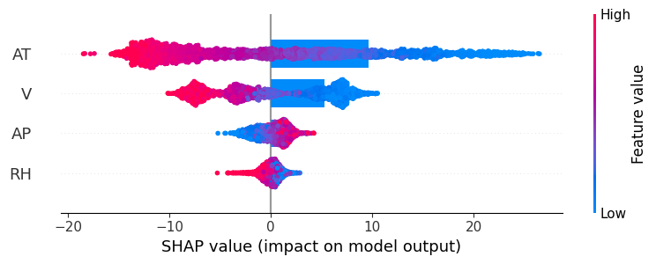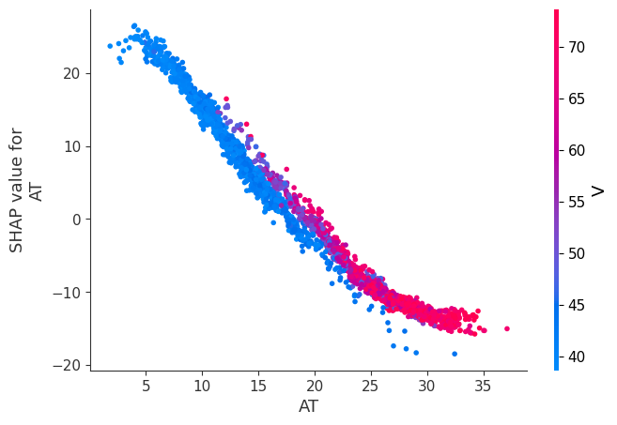
LIME: local explainability
LIME complements SHAP by explaining individual predictions with simple, human-readable rules. For a representative test instance, the LIME explanation shows that conditions such as “AT > 25.71” and “V > 66.54” decrease the local prediction by approximately 18 MW and 8 MW, respectively, while “AP <= 1009.06” reduces it by a further 2 MW and “63.24 < RH < = 75.09” slightly increases the output by about 0.1 MW.
These signed contributions quantify how the specific feature values for this case shift the prediction away from a local baseline and are consistent with the global SHAP patterns that are associate higher temperature and vacuum with lower power output. Overall, combining SHAP and LIME yields a high level of explainability: SHAP offers a global ranking and direction of effect for each feature across the dataset, while LIME provides case-by-case justifications for selected instances, together giving engineers a transparent account of how Random Forest links ambient conditions to predicted power output, albeit still within the limits of post-hoc, correlation-based explanations.
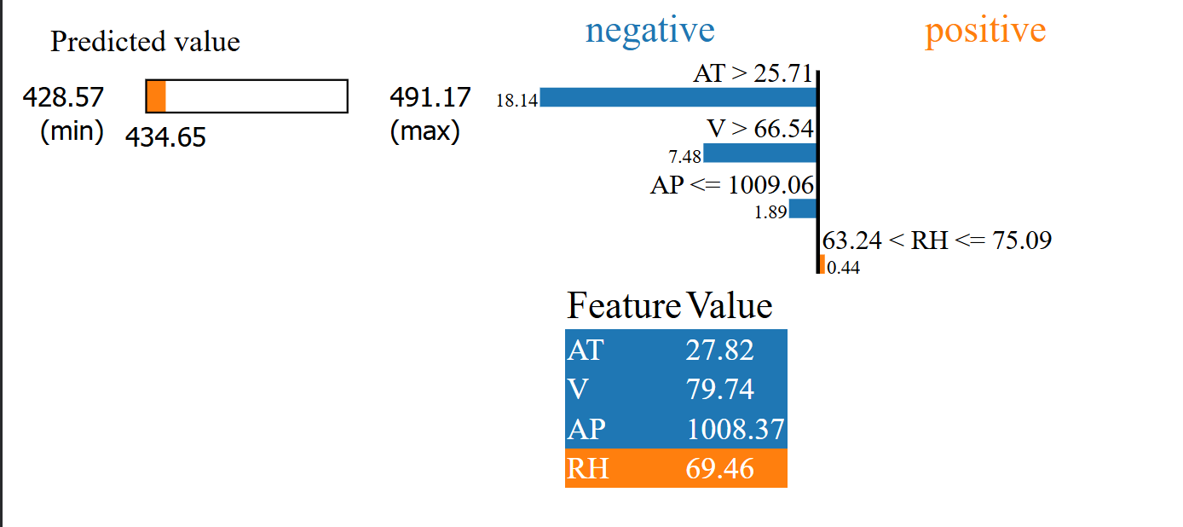

- Conclusion
The project demonstrates that a tuned Random Forest Regressor can accurately predict net hourly power output in the Combined Cycle Power Plant dataset from four ambient condition variables, achieving a test R^2 of about 0.96 with low MAE and RMSE, and clearly outperforming the linear baseline. By combining TreeSHAP for global explanations and LIME for local surrogate explanations, the study showed that higher ambient temperature and exhaust vacuum consistently decrease predicted power output, while ambient pressure and relative humidity exert smaller, secondary effects, yielding a model whose behavior aligns with known power-plant physics and is interpretable at both the dataset and instance level.

However, the work has several limitations. The analysis relies on a single UCI dataset collected from one plant under full-load conditions, so the model and its SHAP/LIME patterns may not generalize to other plants, partial-load regimes, or different climates. Random Forests and SHAP/LIME also remain computationally heavier and less directly interpretable than simple parametric models, and both methods can be affected by feature correlations and do not provide causal explanations. Future work could explore additional model families, such as gradient-boosted trees or neural networks on the same dataset, compare SHAP/LIME with alternative XAI methods, investigate robustness under simulated noise or distribution shifts, and validate the explanation patterns on other power-generation datasets to assess generalizability.

The main findings and limitations of the study are summarized in Table 3
Aspect | Summary
Predictive accuracy | RF achieves test R^2 ~ 0.96 with low MAE/RMSE, outperforming the linear baseline.
Global explanation | SHAP identifies AT and V as dominant features, which are consistent with power-plant physics
Local explanation | LIME provides instance-level contributions that agree with SHAP tends for representative cases.
Data limitations | Single full-load plant from one site; explanation patterns may not generalize to other plants or regimes
Methodological limits | RF + SHAP/LIME are computationally heavier, sensitive to feature correlations, and remain non-causal.

- reference:
- A. S. Antonini et al., “Machine learning model interpretability using SHAP values: Application to igneous rock classification task,” Appl. Compute. Geosci., vol. 23, Art. no. 100178, Jul. 2024, doi: 10.1016/j.acags.2024.100178.
- T. Abekoon, H. Sajindra, N. Rathnayake, I. U. Ekanayake, A. Jayakody, and U. Rathnayake, “A novel application with explainable machine learning (SHAP and LIME) to predict soil N, P, and K nutrient content in cabbage cultivation,” Smart Agric. Technol., vol. 11, Art. no. 100879, Mar. 2025, doi: 10.1016/j.atech.2025.100879.
- R. K. Makumbura et al., “Advancing water quality assessment and prediction using machine learning models, coupled with explainable artificial intelligence (XAI) techniques like Shapley additive explanations (SHAP) for interpreting the black-box nature,” Results Eng., vol. 23, Art. no. 102831, Sep. 2024, doi: 10.1016/j.rineng.2024.102831.
- A. N. Zereen, A. Das, and J. Uddin, “Machine fault diagnosis using audio sensor data and explainable AI techniques—LIME and SHAP,” Comput. Mater. Continua, vol. 80, no. 3, pp. 3463–3484, Jan. 2024, doi: 10.32604/cmc.2024.054886.
- S. Q. U. Ain and K. U. I. Rather, “Integrated statistical modeling and machine learning techniques with SHAP for epidemiological data analysis,” Ann. Epidemiol., vol. 108, pp. 85–91, Jun. 2025, doi: 10.1016/j.annepidem.2025.06.012.

